Digital Agriculture Recommender System
Software Design Specification

BY
Name: Muhammad Anas Qadri CMS ID: 053-24-0016
Name: Talha Irfan CMS ID: 053-24-0013
Name: Ghulam Mustafa CMS ID: 053-24-0018



DEPARTMENT OF COMPUTER SCIENCE
FACULTY OF SCIENCE AND INFORMATION TECHNOLOGY
SUKKUR IBA UNIVERSITY

December 2025

1. Introduction 1
1.1. Purpose of Document 1
1.2. Definitions, acronyms, and abbreviations 1
2. Overall System Description 2
2.1. Project Background 2
2.2. Project Objectives 2
3. System Architecture 2
4. Domain Model 5
5. Class Diagram 10
6. Database Diagram 13
7. Entity Relationship Diagram (ERD) 17
8. Sequence Diagram 19
9. System Interface Design 32
10. Test Cases 41

- Introduction

  - Purpose of Document
- This document explains how the Digital Agriculture Recommender System (DARS) is designed.
- It gives a simple blueprint that helps developers understand how to build the system.
- It shows the system architecture, main components, database design, and how different parts work together.
- It translates the requirements from the SRS into a clear technical design.
- It helps the team keep the design consistent, clear, and easy to follow.
- It also acts as a reference for future updates or maintenance.
  - Definitions, acronyms, and abbreviations
Document conventions (style & fonts)
- Headings: Bold, sentence case.
- Body text: 11–12 pt, readable font (e.g., Arial).
- Tables: simple borders, header row bold.
Abbreviations & acronyms
- UI – User Interface (the part users see and use)
- DBMS – Database Management System (stores and manages data)
- CRUD – Create, Read, Update, Delete (basic database actions)
- API – Application Programming Interface (lets different software parts communicate)
- ERD – Entity Relationship Diagram (shows database structure)
- MVC – Model-View-Controller (design pattern for organizing code)
- Backend – Server-side part where logic and database work happen
- Frontend – Client-side part that users interact with
- Recommendation Engine – The system part that gives crop, soil, and treatment suggestions
- Soil Analysis Module – Checks soil data and matches it with suitable crops
- Disease Diagnosis Module – Finds possible crop diseases and gives treatment suggestions
- Spatio-temporal Data – Data that includes location and time (like crop trends in different seasons)

- Overall System Description
  - Project Background
- Many farmers choose crops based on past experience or last year's market, which often causes overproduction or low supply of important crops.
- There is no simple web system that gives direct crop, soil, and disease recommendations.
- The Digital Agriculture Recommender System (DARS) is created to solve this problem.
- It helps farmers by giving easy suggestions like:
  - which crop to grow,
  - which soil is suitable,
  - how to treat crop diseases,
  - and what crops may be needed in the coming season.
- This SDS explains the technical design needed to build this system.
  - Project Objectives
- Build a simple, rule-based web application for agriculture support.
- Give crop recommendations based on soil, season, and local conditions.
- Give disease treatment suggestions for common crop problems.
- Give soil suitability info to help farmers choose the right crop.
- Create a clean and modular design that is easy to update and maintain.
- Provide separate modules for normal users (farmers) and admin users.
- Help farmers make better, data-based decisions instead of guessing.

- System Architecture
The Digital Agriculture Recommender System (DARS) uses a Three-Tier MVC-based Architecture, ensuring scalability, easy maintenance, and clear separation of responsibilities.
Three Main Layers
- Presentation Layer (Frontend)
- Application / Business Logic Layer (Backend)
- Data Layer (Database)
  - Presentation Layer (Frontend)
Handles everything the user sees and interacts with through the web interface.
Responsibilities
- User login, signup, and authentication.
- Farmer inputs:
  - Soil information
  - Region / season
  - Observed disease symptoms
- Display of system outputs:
  - Crop recommendations
  - Soil–crop suitability results
  - Disease treatment suggestions
  - Seasonal/demand forecasts
- Admin/Agronomist functions:
  - Manage crop/soil/disease datasets
  - Update recommendation rules
  - View usage dashboards and reports
Technologies
- HTML, CSS, JavaScript
- (Optional) React / Vue / Angular
- REST API communication via JSON
  - Application / Business Logic Layer (Backend)
This layer performs all processing, decision-making, and rule execution. It manages communication between UI and database.
Main Components
- Recommendation Engine
  - Rule-based inferencing
  - Soil → Crop matching
  - Disease → Treatment mapping
  - Seasonal demand prediction (historical patterns)
- Spatio-Temporal Context Module
  - Uses region + season to refine recommendations
- Demand Forecasting Module
  - Uses historical demand/seasonal trends
- Authentication & Authorization
  - Role-based access: Farmer, Admin, Agronomist
  - Secure login/session management (JWT or session)
- API Service / Controller Layer
  - Handles incoming requests
  - Validates user inputs
  - Returns processed results to the frontend
- Responsibilities
  - Execute agricultural rules and logic.
  - Process farmer inputs.
  - Retrieve and combine data from the database.
  - Generate outputs in a structured format.
  - Coordinate workflow across modules.
- Possible Technologies
  - Python Django / PHP Laravel / Node.js (any one)
  - RESTful API design

  - Data Layer (Database)
Stores all persistent data required for recommendations, rule evaluation, and system management.
Stored Data
- Farmer profiles and user accounts
- Soil test records (pH, nutrients, soil type)
- Crop dataset (seasons, requirements, attributes)
- Disease knowledge base (symptoms + treatments)
- Historical demand and seasonal trends
- Recommendation rules and mappings
- Admin/agronomist management data
Responsibilities
- Provide secure, structured storage for system data.
- Maintain data integrity through relationships and constraints.
- Support fast querying for real-time recommendations.
- Ensure scalability for future dataset expansion.
Possible Technologies
- MySQL / PostgreSQL
- Optional cloud-hosted database
  - Simplified System Flow
- The user interacts with the website (Presentation Layer).
- The backend receives the request, applies rules, and processes logic.
- The database provides required information (soil, crop, disease, rules).
- The backend produces recommendations and sends results back to the user interface.
  - System Architecture Diagram
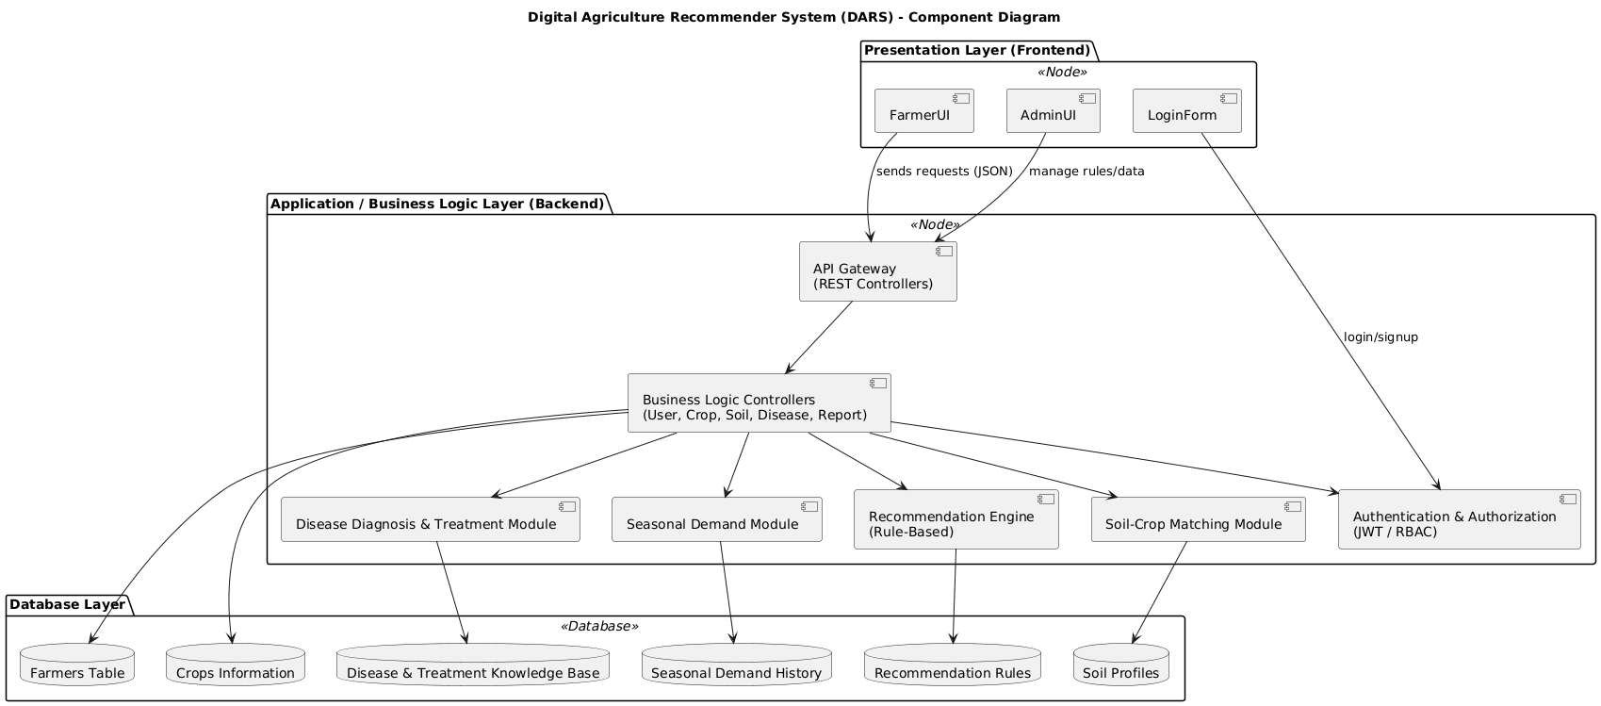

- Domain Model
The Domain Model defines the core business entities of the Digital Agriculture Recommender System (DARS) and explains how they interact to support crop recommendation, soil suitability analysis, disease diagnosis, and demand forecasting.
This model is technology-independent and focuses on the conceptual structure of the system.
  - Domain Entities and Descriptions
Farmer
Represents the primary user receiving recommendations.
- Attributes
- farmerID
- name
- location
- soilID (references the farmer’s primary soil profile)
- credentials
- Responsibilities
- Requests crop and soil recommendations
- Provides soil details and disease symptoms
- Views disease advice and demand insights

Soil
Represents soil characteristics that influence crop suitability.
- Attributes
- soilID
- type (clay, loamy, sandy, etc.)
- pHLevel
- fertility / NPK profile
- Responsibilities
- Determines crop suitability
- Used in soil–crop rule matching
- Linked to a farmer's profile

Crop
Represents crops in the agricultural knowledge base.
- Attributes
- cropID
- name
- season
- nutrientNeeds
- growthPeriod
- marketDemand level
- Responsibilities
- Used in recommendation generation
- Evaluated against soil and climate factors
- May be affected by diseases
- Included in final recommendations

Disease
Represents crop diseases and their symptoms.
- Attributes
- diseaseID
- name
- symptoms
- treatmentGuidelines
- Responsibilities
- Matched with symptoms reported by farmers
- Provides disease advice in recommendations
- Linked to one or more crops

Treatment
Represents actionable treatment options for diseases.
- Attributes
- treatmentID
- description
- chemicals
- organicOptions
- duration
- effectiveness (optional)
- Responsibilities
- Stores recommended treatments for each disease
- Used by disease advisory module
- Attached to a disease (1 disease → many treatments)

Recommendation
Represents the final generated advice given to the farmer.
- Attributes
- recID
- farmerID (FK)
- dateGenerated
- recommendedCrops
- soilAdvice
- diseaseAdvice
- demandForecast
- Responsibilities
- Combines input from crop, soil, disease, and demand modules
- Produced by the rule-based inference engine
- Stored for future viewing

Admin
Maintains system data and business rules.
- Attributes
- adminID
- name
- role (Admin / Agronomist)
- credentials
- Responsibilities
- Manages crop, soil, disease, and treatment datasets
- Creates/updates RuleSet entries
- Ensures accuracy of recommendation logic

Rule Set
Represents the rule-based logic driving recommendations.
- Attributes
- ruleID
- condition (IF-part)
- action (THEN-part)
- priority
- Responsibilities
- Executes crop, soil, disease, and demand rules
- Controls how recommendations are generated
- Updated by Admin/Agronomist

Demand Trend
Represents historical/seasonal crop demand patterns.
- Attributes
- trendID
- cropID (FK)
- season
- year
- demandValue
- Responsibilities
- Supports demand forecasting
- Helps determine which crops will be in high demand next season

  - Full Relationship Summary

Entity | Relationship | Entity | Description
Farmer | requests | Recommendation | A farmer receives many recommendations
Recommendation | uses | Crop | Crops included in suggested list
Recommendation | uses | Soil | Soil profile used for advice
Recommendation | uses | Disease/Treatment | Included if symptoms exist
Soil | suitable for | Crop | Soil supports multiple crops
Crop | affected by | Disease | Many crops may be impacted by many diseases
Disease | has | Treatment | One disease can have many treatments
Admin | manages | RuleSet | Admin maintains the rule base
DemandTrend | linked to | Crop | Used for seasonal/demand forecasting

  - Domain Model Diagram
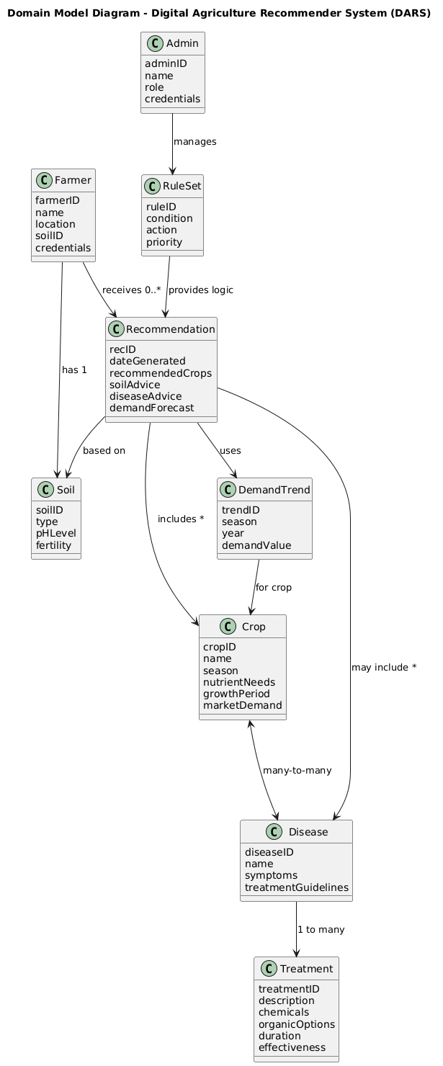
- Class Diagram
The Class Diagram represents the object-oriented structure of the Digital Agriculture Recommender System (DARS). It defines major classes, attributes, operations, inheritance, and key relationships used during implementation.
  - UML Class Diagram
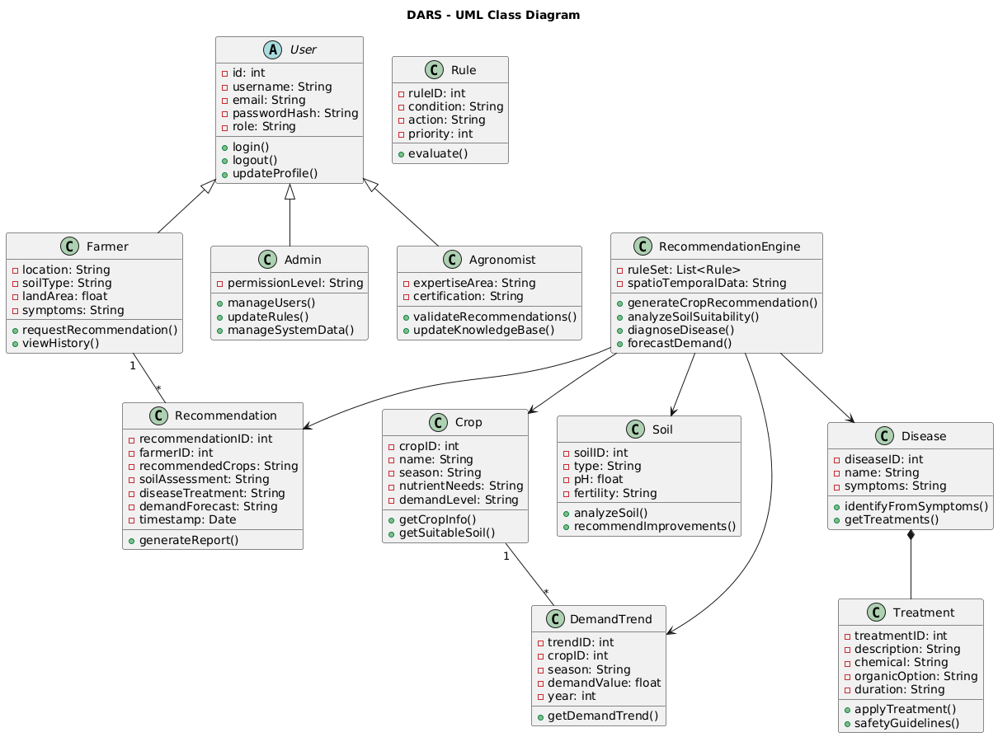5.2. Class Description
User (Abstract Class)
Represents all system users (Farmers, Admins, Agronomists). Provides core authentication and profile features.
- Attributes
- id: int
- username: String
- email: String
- password: String
- role: String
- Methods
- login()
- logout()
- updateProfile()

Farmer
Main system user requesting agricultural recommendations.
- Attributes
  - location: String
  - soilType: String
  - landArea: float
  - symptoms: String
- Methods
- requestRecommendation()
- viewHistory()

Admin
Manages system data and maintains platform integrity.
- Attributes
- permissionLevel: String
- Methods
- manageUsers()
- updateRules()
- manageSystemData()

Agronomist
Domain expert providing validation and updates to agricultural knowledge.
- Attributes
- expertiseArea: String
- certification: String
- Methods
- validateRecommendations()
- updateKnowledgeBase()

5. Crop
Represents crop-related data.
- Attributes
- cropID: int
- name: String
- season: String
- nutrientNeeds: String
- demandLevel: String
- Methods
- getCropInfo()
- getSuitableSoil()

6. Soil
Represents soil characteristics used in recommendations.
- Attributes
- soilID: int
- type: String
- pH: float
- fertility: String
- Methods
- analyzeSoil()
- recommendImprovements()
7. Disease
Represents plant diseases and symptom matching.
- Attributes
- diseaseID : int
- name : String
- symptoms : String
- Methods
- identifyFromSymptoms()
- getTreatments()

8. Treatment (Composition with Disease)
Provides treatment suggestions for diseases.
- Attributes
- treatmentID : int
- description : String
- chemical : String
- organicOption : String
- duration : String
- Methods
- applyTreatment()
- safetyGuidelines()

9. DemandTrend
Historical demand data supporting forecasting.
- Attributes
- trendID : int
- cropID : int
- season : String
- demandValue : float
- year : int
- Methods
- getDemandTrend()

10. Rule
Represents rule-based logic behind recommendations.
- Attributes
- ruleID : int
- condition : String
- action : String
- priority : int
- Methods
- evaluate()

11. RecommendationEngine
Core module for all system intelligence.
- Attributes
- ruleSet : List<Rule>
- spatioTemporalData : String
- Methods
- generateCropRecommendation()
- analyzeSoilSuitability()
- diagnoseDisease()
- forecastDemand()

12. Recommendation
Final combined output provided to the farmer.
- Attributes
- recommendationID : int
- farmerID : int
- recommendedCrops : String
- soilAssessment : String
- diseaseTreatment : String
- demandForecast : String
- timestamp : Date
- Methods
- generateReport()

- Database Diagram
The database of the Digital Agriculture Recommender System (DARS) is designed to support crop recommendations, soil assessment, disease diagnosis, seasonal demand forecasting, user authentication, and system administration.
It follows a normalized relational model (3NF) with well-defined entities, relationships, and foreign-key constraints.
  - Database Diagram
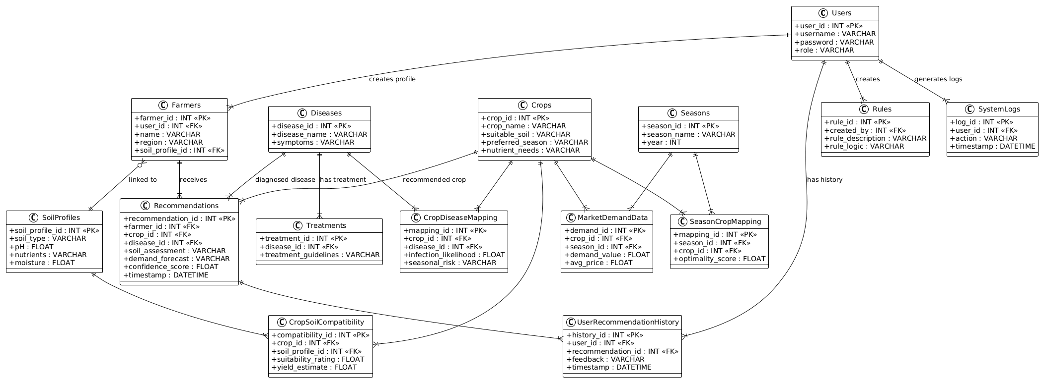
  - Database Tables Overview
Table Name | Description
Users | Stores authentication data for all types of users (Farmer, Admin, Agronomist).
Farmers | Stores agricultural profile of farmers.
SoilProfiles | Stores soil characteristics and properties.
Crops | Stores all crop types and their properties.
CropSoilCompatibility | Junction table mapping crops to compatible soil profiles.
Diseases | Stores disease information.
CropDiseaseMapping | Junction table linking crops with diseases.
Treatments | Treatment recommendations for diseases.
Recommendations | Stores generated system recommendations.
Seasons | Seasonal information such as Kharif/Rabi.
SeasonCropMapping | Junction table linking crops with seasons.
MarketDemandData | Historical demand and pricing for demand forecasting.
Rules | Rule-based logic for the recommendation engine.
UserRecommendationHistory | Logs of recommendations accessed by users.
SystemLogs | Tracks actions performed by users.

  - Detailed Table Descriptions
Below are the tables with fields, types, PKs, FKs, and descriptions.
Users
Central authentication table for the entire system.
Field | Type | Description
user_id (PK) | INT | Unique ID
username | VARCHAR | Login username
password_hash | VARCHAR | Hashed password
role | VARCHAR | farmer/admin/agronomist

Farmers
Stores farmer-specific agricultural data.
Field | Type | Description
farmer_id (PK) | INT | Unique farmer ID
user_id (FK) | INT | Linked to Users table
soil_profile_id (FK) | INT | Linked to SoilProfiles
region | VARCHAR | Geographical region
land_area | FLOAT | Size of farmland

SoilProfiles
Field | Type | Description
soil_profile_id (PK) | INT | Unique soil entry
soil_type | VARCHAR | Clay, Loam, Sandy, etc.
pH | FLOAT | Soil pH level
nutrients | VARCHAR | NPK composition
moisture | FLOAT | Moisture percentage

Crops
Field | Type | Description
crop_id (PK) | INT | Unique crop ID
crop_name | VARCHAR | Name of crop
preferred_season | VARCHAR | Kharif/Rabi/All
nutrient_needs | VARCHAR | Required nutrients

CropSoilCompatibility
Junction table linking crops with suitable soil types.
Field | Type | Description
compatibility_id (PK) | INT | Unique ID
crop_id (FK) | INT | Crop reference
soil_profile_id (FK) | INT | Soil reference
suitability_rating | FLOAT | Rating 1–5

Diseases
Field | Type | Description
disease_id (PK) | INT | Unique ID
disease_name | VARCHAR | Disease name
symptoms | VARCHAR | Symptom list

CropDiseaseMapping
Maps which crops are vulnerable to which diseases.
Field | Type | Description
mapping_id (PK) | INT | Unique ID
crop_id (FK) | INT | Linked crop
disease_id (FK) | INT | Linked disease
vulnerability_level | VARCHAR | Low/Medium/High

Treatments
Field | Type | Description
treatment_id (PK) | INT | Unique ID
disease_id (FK) | INT | Linked disease
treatment_guideline | VARCHAR | Chemical & organic solutions
duration | VARCHAR | Treatment duration

Recommendations
Field | Type | Description
recommendation_id (PK) | INT | Unique ID
farmer_id (FK) | INT | Requesting farmer
crop_id (FK) | INT | Recommended crop
disease_id (FK) | INT | Diagnosed disease (nullable)
soil_assessment | VARCHAR | Soil suitability explanation
demand_forecast | VARCHAR | Seasonal market trend
timestamp | DATETIME | Time of generation

Seasons
Field | Type | Description
season_id (PK) | INT | Unique ID
season_name | VARCHAR | Kharif, Rabi
year | INT | Data year

SeasonCropMapping
Links crops to suitable growing seasons.
Field | Type | Description
mapping_id (PK) | INT | Unique ID
season_id (FK) | INT | Season
crop_id (FK) | INT | Crop

MarketDemandData
Field | Type | Description
demand_id (PK) | INT | Unique ID
crop_id (FK) | INT | Crop
season_id (FK) | INT | Season
demand_value | FLOAT | Market demand indicator

Rules
Field | Type | Description
rule_id (PK) | INT | Unique ID
created_by (FK) | INT | User who created rule
condition | VARCHAR | IF part
action | VARCHAR | THEN part
priority | INT | Rule precedence

UserRecommendationHistory
Field | Type | Description
history_id (PK) | INT | Unique log ID
user_id (FK) | INT | User
recommendation_id (FK) | INT | Recommendation
feedback | VARCHAR | User feedback (optional)

SystemLogs
Field | Type | Description
log_id (PK) | INT | Log ID
user_id (FK) | INT | User performing action
action | VARCHAR | Action description
timestamp | DATETIME | When it happened
  - Relationship Summary
From | To | Type
Farmers | Users | Many-to-One
Farmers | SoilProfiles | Many-to-One
Recommendations | Farmers | Many-to-One
Recommendations | Crops | Many-to-One
Recommendations | Diseases | Many-to-One
CropSoilCompatibility | Crops | Many-to-One
CropSoilCompatibility | SoilProfiles | Many-to-One
CropDiseaseMapping | Crops | Many-to-One
CropDiseaseMapping | Diseases | Many-to-One
Treatments | Diseases | Many-to-One
SeasonCropMapping | Crops | Many-to-One
SeasonCropMapping | Seasons | Many-to-One
MarketDemandData | Crops | Many-to-One
MarketDemandData | Seasons | Many-to-One
Rules | Users | Many-to-One
UserRecommendationHistory | Users | Many-to-One
UserRecommendationHistory | Recommendations | Many-to-One
SystemLogs | Users | Many-to-One

- Entity Relationship Diagram (ERD)
The Entity Relationship Diagram (ERD) represents the conceptual data model of the Digital Agriculture Recommender System (DARS).
It focuses on logical business entities, their attributes, and the relationships required to generate intelligent recommendations.
This ERD is conceptual, meaning it avoids implementation details like join tables and focuses strictly on business meaning.
  - ERD Entities
The major entities in the conceptual model are:
- Farmer – Represents the system’s primary user
- SoilProfile – Contains soil characteristics used for decision-making
- Crop – Represents agricultural crops
- Disease – Represents diseases affecting crops
- Recommendation – System-generated output delivered to farmers
- Season – Represents seasonality affecting crops
- Admin – System management and rule maintenance role
  - Key Relationships
- SoilProfile ↔ Farmer
- One SoilProfile can be linked to many Farmers
- Each Farmer has exactly one SoilProfile
- SoilProfile (1) —— (M) Farmer
- Farmer ↔ Recommendation
- One Farmer can receive many Recommendations
- Each Recommendation is generated for one Farmer
- Farmer (1) —— (M) Recommendation
- Crop ↔ Recommendation
- A Crop may appear in many Recommendations
- Each Recommendation includes one Crop
- Crop (1) —— (M) Recommendation
- Disease ↔ Recommendation
- One Disease can appear in multiple Recommendations
- Each Recommendation can reference one Disease
- Disease (1) —— (M) Recommendation
- Crop ↔ Season
- Crops can be grown in multiple seasons
- Each Seasonal Demand entry refers to one Crop
- Crop (1) —— (M) Season
- Admin (Standalone Role)
- Admin is not directly connected because it exists solely for system rule management and access control.

  - Database Diagram
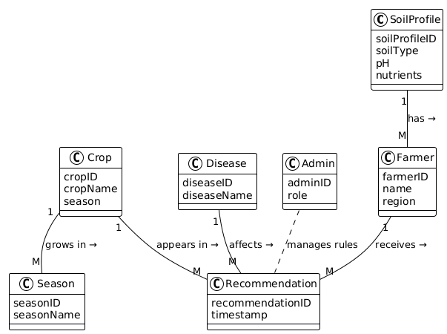

- Sequence Diagram
This sequence diagram shows the interaction when a Farmer requests a crop recommendation. The system collects soil data, seasonal demand, disease symptoms, applies rules, and generates a recommendation.
Participants (lifelines):
- Farmer (UI)
- Auth Service
- API Gateway / Controller
- Recommendation Engine
- Database
Main Flow
- Farmer → UI: Selects criteria and clicks "Get Recommendation"
- UI → Auth Service: Sends login/session token for verification
- Auth Service → UI: Returns session validation (OK)
- UI → API Gateway: Sends recommendation request (token, soilData, season, region, symptoms)
- API Gateway → Auth Service: Validates token
- Auth Service → API Gateway: Token valid, returns farmerID
- API Gateway → Database: Retrieve farmer soil profile and crop/demand rules
- Database → API Gateway: Return soil profile & demand trend
- API Gateway → Recommendation Engine: generateRecommendation(farmerID, soilData, season, region, symptoms, demandTrend)
- Recommendation Engine → Database: Fetch crop rules, disease knowledge base
- Recommendation Engine: Applies rules to determine suitable crops, disease treatment, and demand forecast
- Recommendation Engine → Database: Inserts new Recommendation record
- Database → Recommendation Engine: Confirms insert + recommendationID
- Recommendation Engine → API Gateway: Returns recommendation payload
- API Gateway → Farmer (UI): Displays recommendation (crops, soil advice, disease treatment, demand forecast)
UseCase 01:
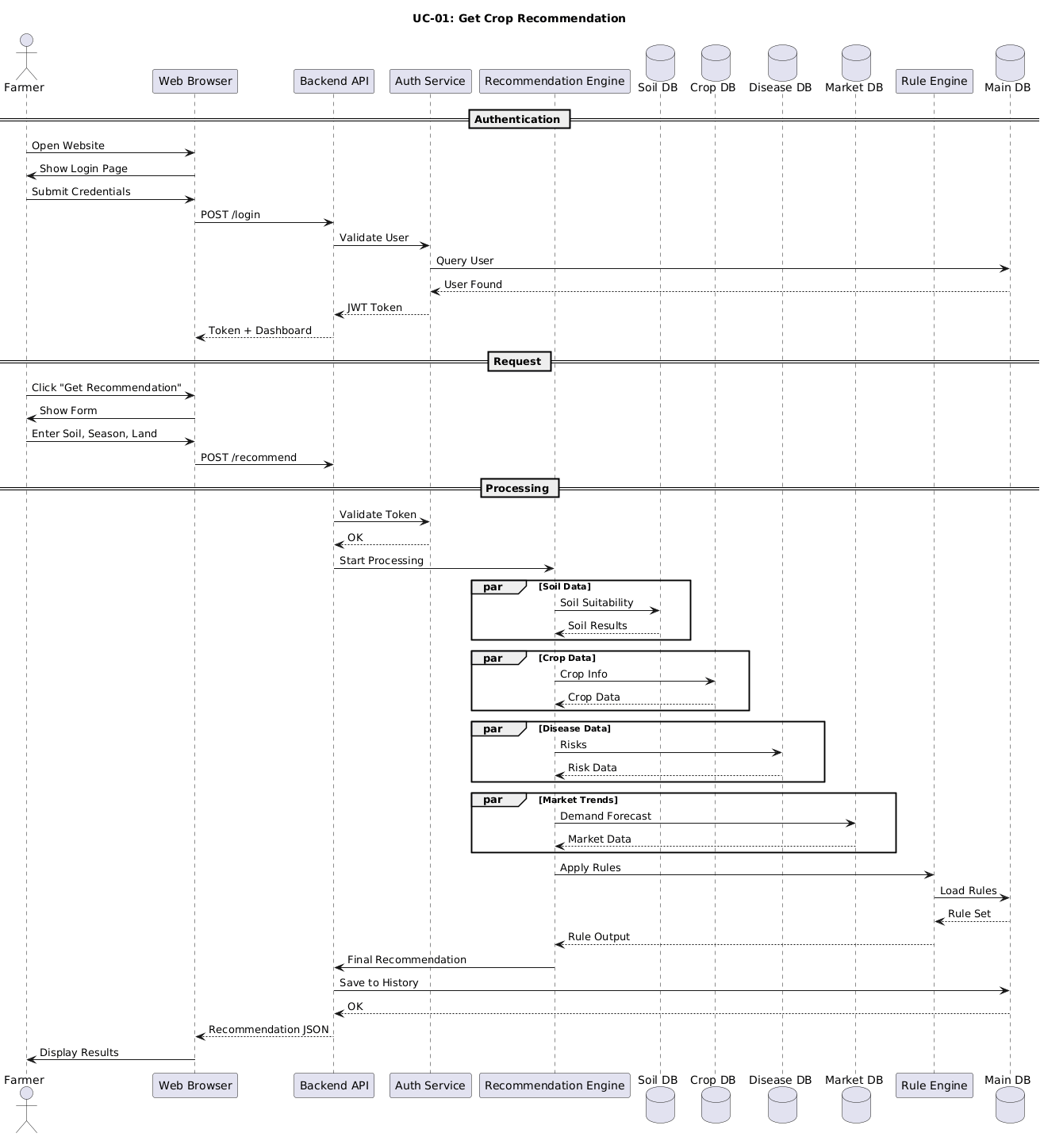
UseCase 02:
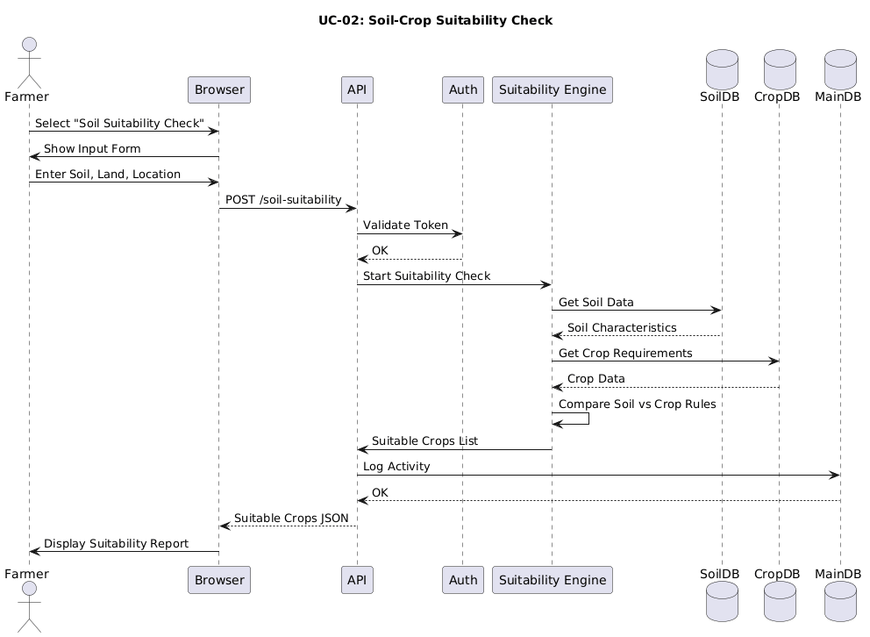
UseCase 03:
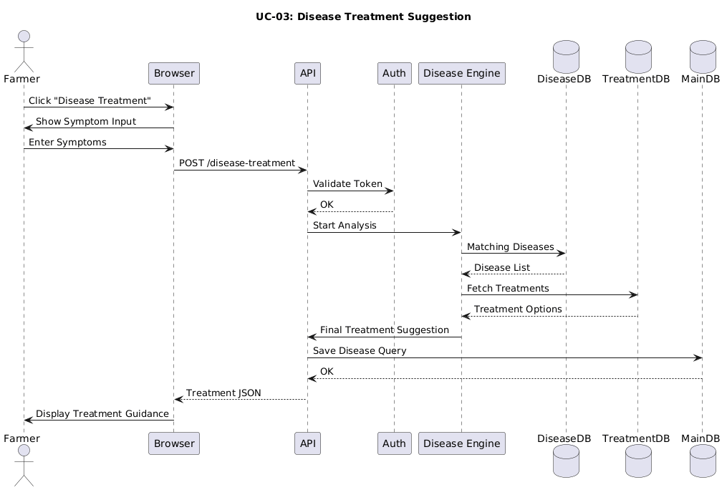
UseCase 04:
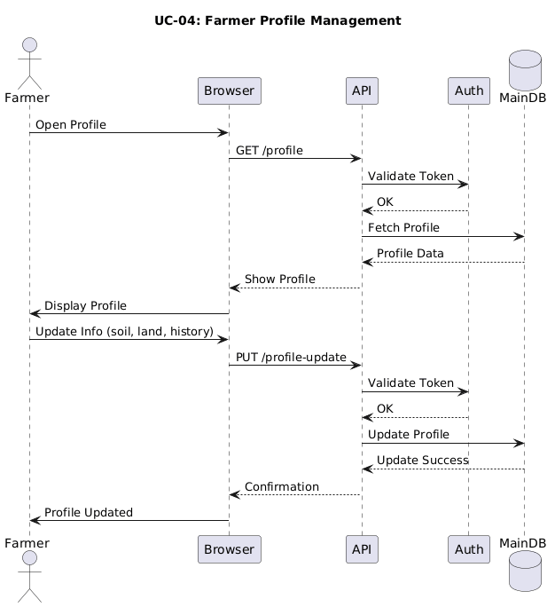
UseCase 05:
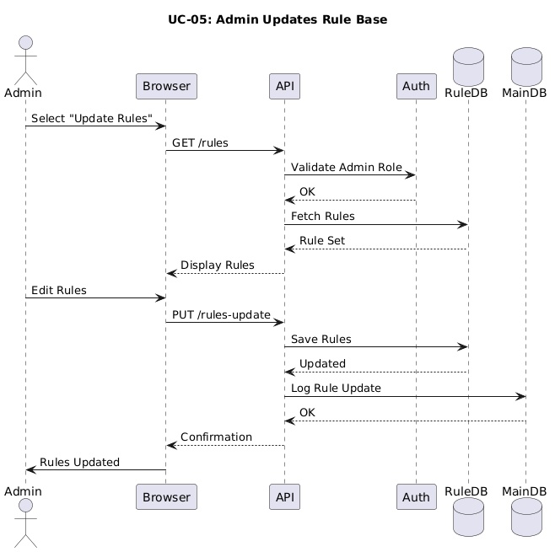
UseCase 06:
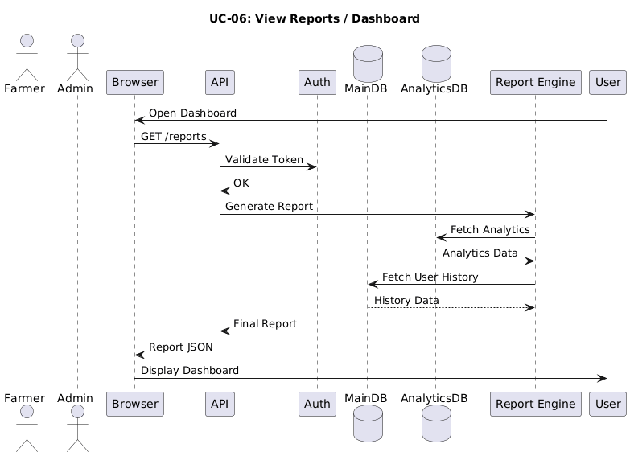
UseCase 07:
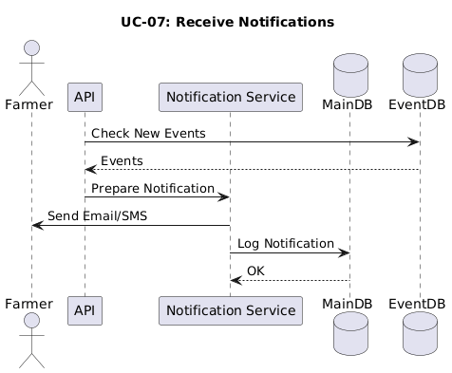
UseCase 08:
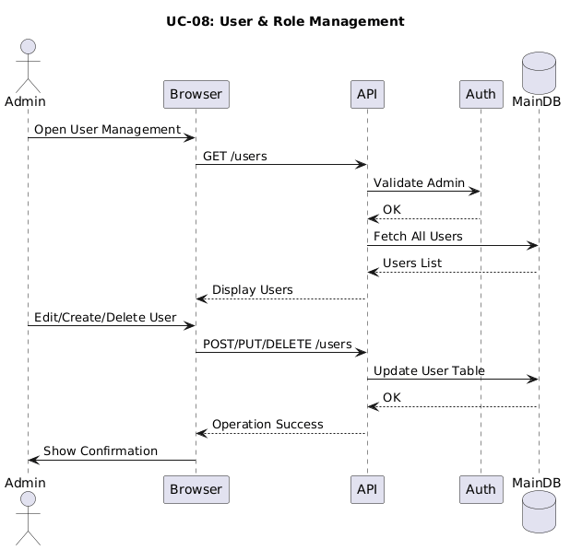
UseCase 09:
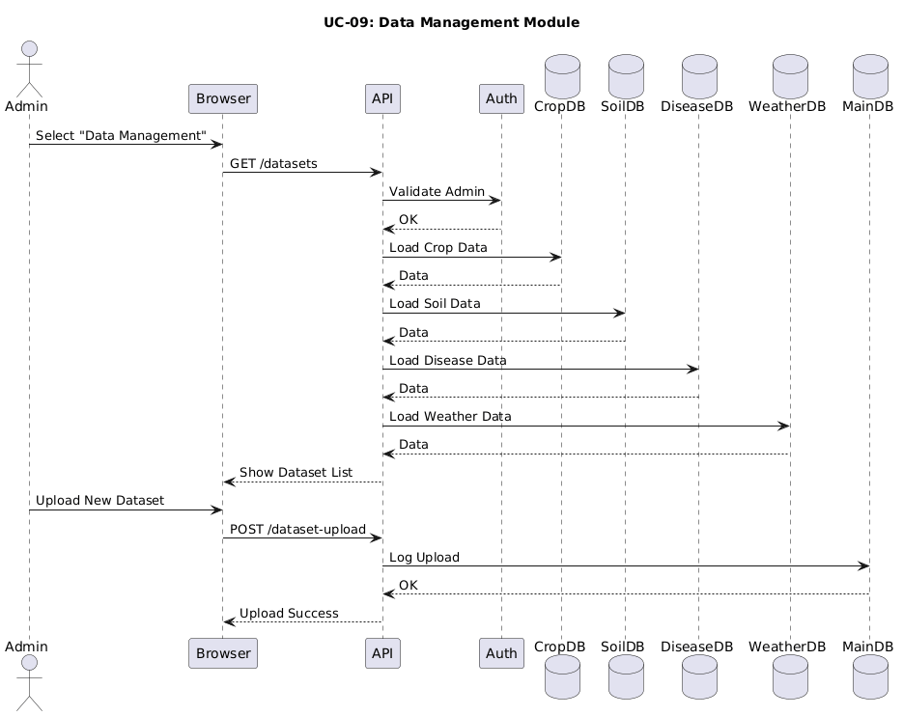
UseCase 10:
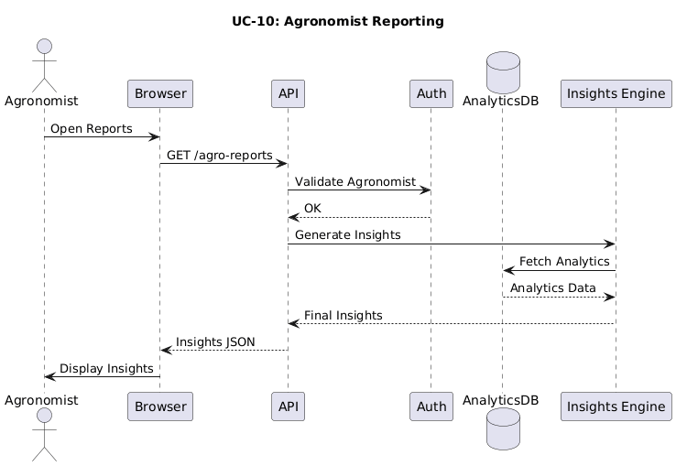
UseCase 11:
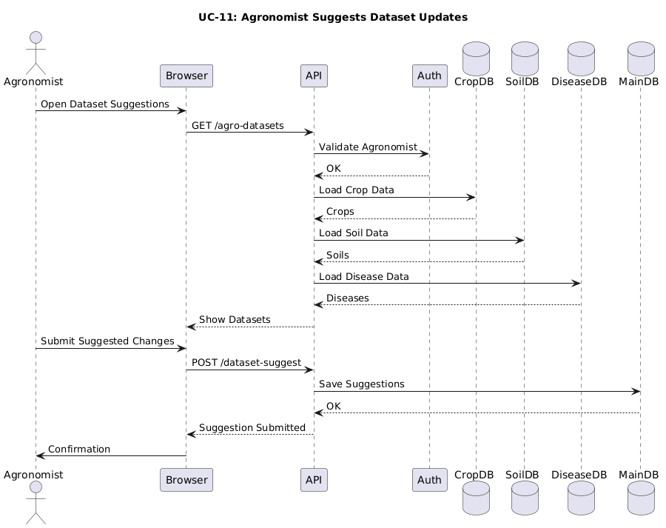
UseCase 12:
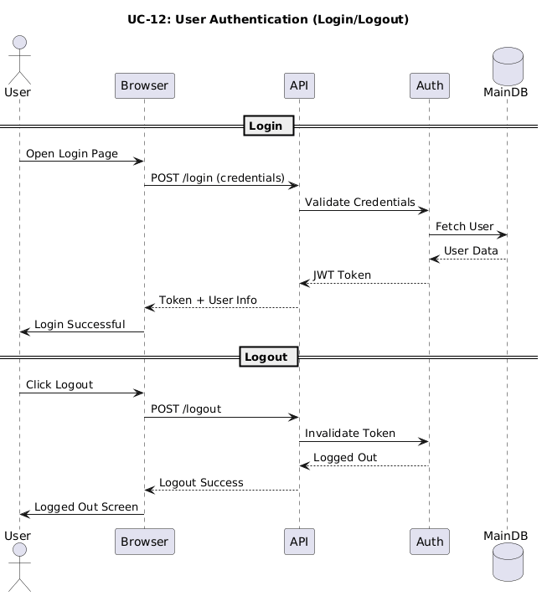
- System Interface Design
This section presents the user interface (UI) design of the Digital Agriculture Recommender System (DARS). The design prioritizes simplicity, clarity, and accessibility for farmers, while providing advanced management features for admins.
Login Screen (Farmer / Admin)
Simple authentication screen for all user roles with access to login.
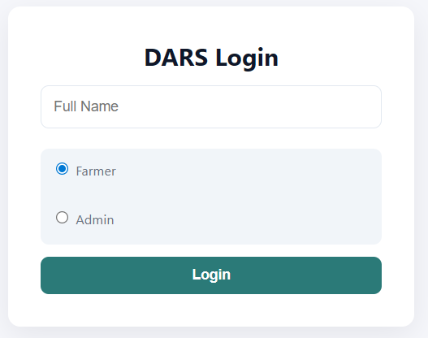
Farmer Dashboard
Central hub for all farmer operations with clear navigation and quick access.
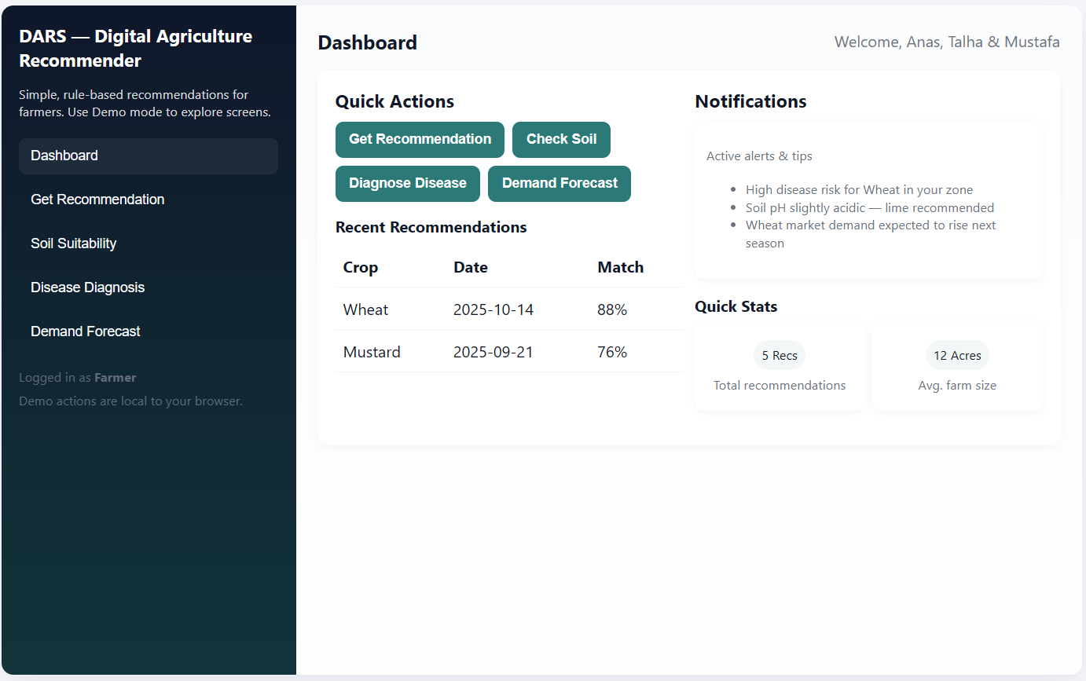
Soil Input Form
Allows farmers to manually enter soil information for suitability assessment.
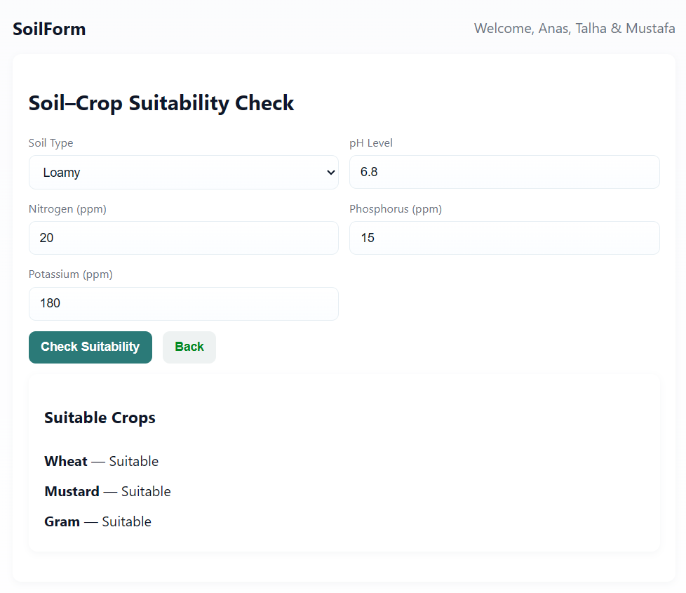
Crop Recommendation Screen
Displays crop recommendations with match percentage, soil notes, and demand trends.
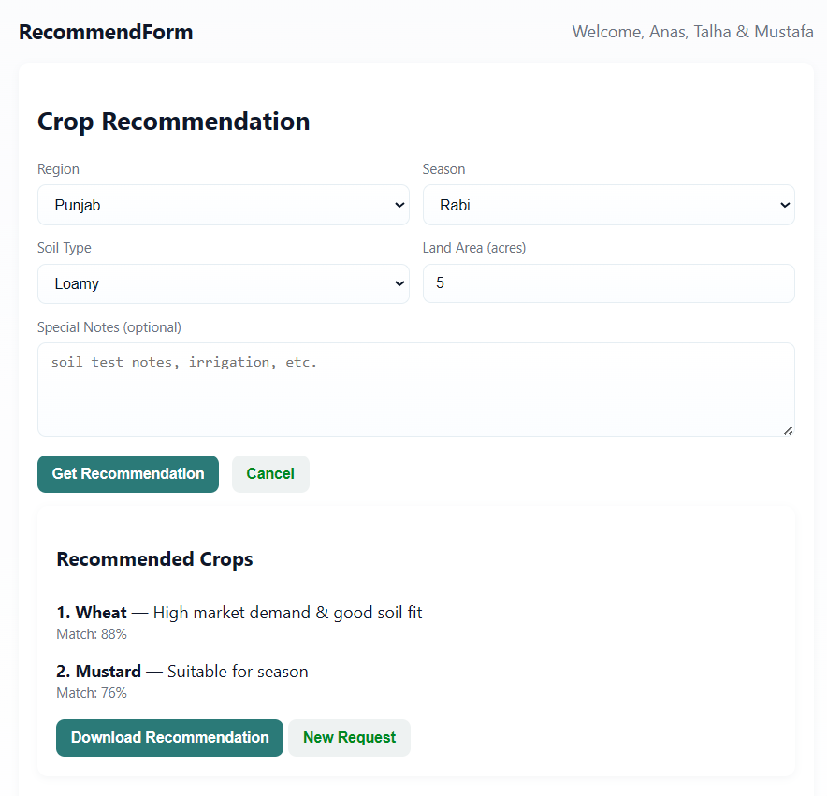
Disease Diagnosis Interface
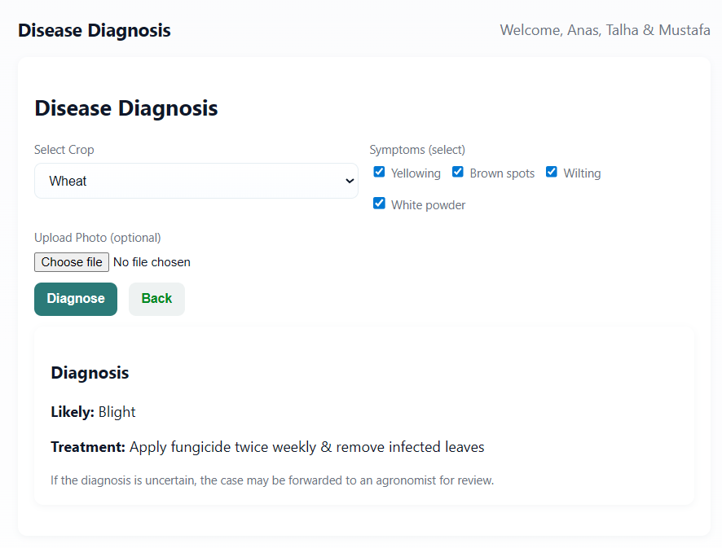
Seasonal Demand Forecast Screen
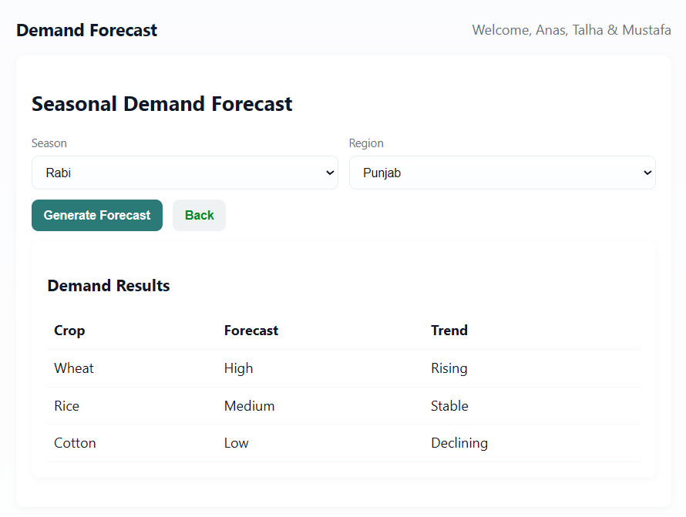
Admin Panel Dashboard
Complete database and rule-engine management interface for admins/agronomists.

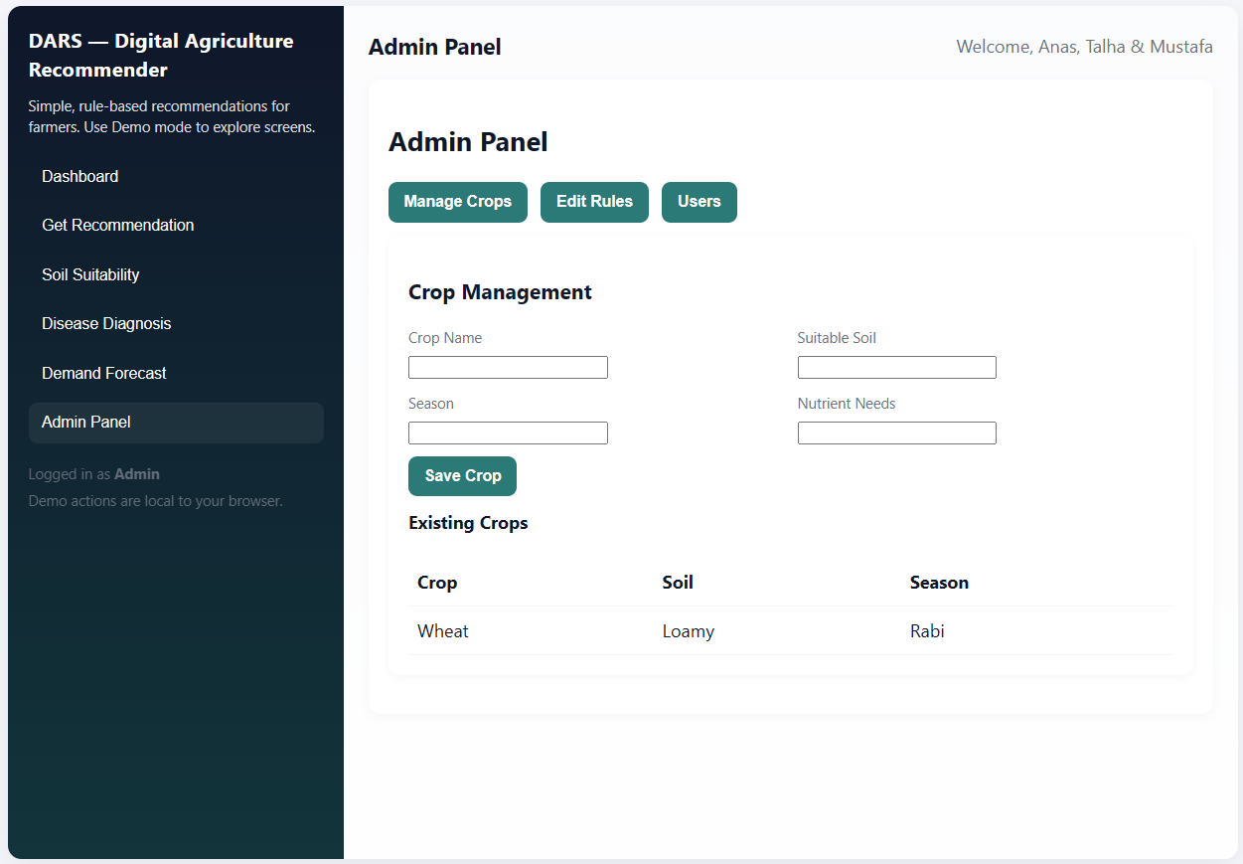
Admin – Rule Editor
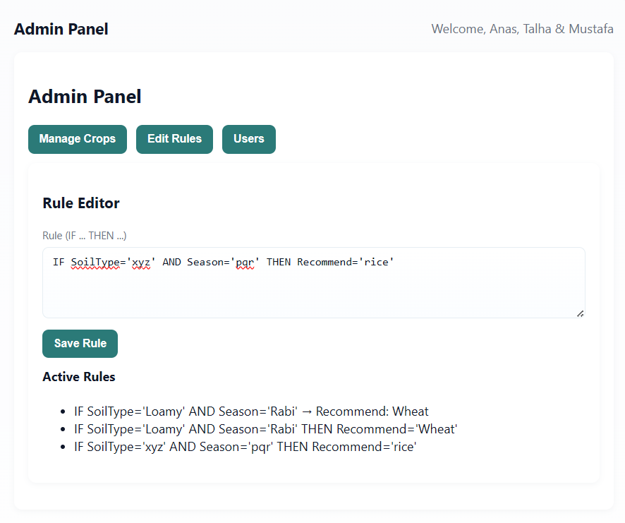
Admin – Crop Management Screen
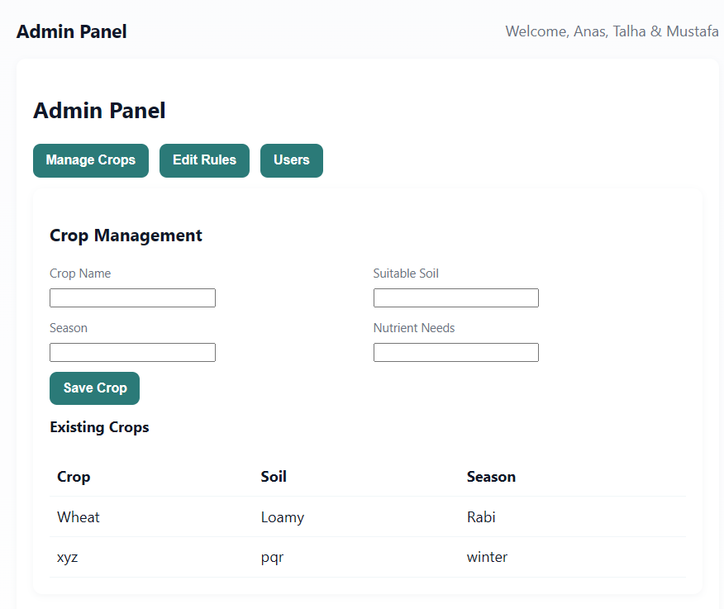

- Test Cases
Authentication Module Test Cases
- TC-AUTH-01: Valid User Login
Objective: Verify valid credentials allow access
Preconditions: User exists
Inputs:
- Username: farmer_ali
- Password: SecurePass123
Expected Output:
- Login successful
- Redirect to Dashboard
- TC-AUTH-02: Invalid User Login
Objective: Reject wrong credentials
Inputs:
  - Username: wronguser
  - Password: wrongpass
Expected Output:
- Message: “Invalid credentials”
- No redirection
- TC-AUTH-03: Password Strength Validation
Objective: Enforce secure password rules
Inputs: Weak password: 12345
Expected Output:
- Message: “Password must be at least 8 characters with uppercase, lowercase, and number”
Farmer Module Test Cases
- TC-FARM-01: Crop Recommendation Request
Objective: Validate correct recommendation generation
Preconditions: Soil DB populated
Inputs:
- Soil: Loamy
- Season: Rabi
- Location: Punjab
- Area: 5 acres
Expected Output:
- 2–3 crops recommended (Wheat, Mustard, etc.)
- Confidence % shown
- Soil advice + disease warnings
- Response < 3 seconds
- TC-FARM-02: Soil Suitability Check
Objective: Validate soil–crop matches
Inputs:
- Soil: Sandy
Expected Output:
- List of suitable crops
- Compatibility rating
- Response < 2 seconds
- TC-FARM-03: Disease Diagnosis
Objective: Match symptoms with known diseases
Inputs:
- Crop: Wheat
- Symptoms: Yellow leaves, brown spots
Expected Output:
- Disease: Yellow Rust / Leaf Blight
- Treatment suggestions
- Preventive measures
- TC-FARM-04: Invalid Input Handling
Objective: Validate numeric fields
Inputs:
- Land area: -5
Expected Output:
- Message: “Land area must be a positive number”
Admin Module Test Cases
- TC-ADMIN-01: Add New Crop
Objective: Check crop creation
Inputs:
- Crop: Quinoa
- Season: Rabi
- Water Need: Low
Expected Output:
- “Crop added successfully”
- Crop visible in crop list
- TC-ADMIN-02: Update Rule Set
Objective: Verify rule updates
Inputs:
- Modify rule: IF season=Rabi AND temperature>15 THEN recommend Wheat
Expected Output:
- Rule updated
- Engine reloads without crashing
- TC-ADMIN-03: User Management
Objective: Deactivate user
Inputs:
- User: test_farmer
Expected Output:
- User deactivated
- User cannot log in
Recommendation Engine Test Cases
- TC-REC-01: Rule-Based Inference Logic
Objective: Ensure rule engine applies logic correctly
Inputs:
- Soil: Loamy
- Season: Rabi
Expected Output:
- Wheat recommended with high confidence
- TC-REC-02: Performance Testing
Objective: Validate speed under load
Inputs: 100 concurrent recommendation requests
Expected Output:
- Avg. response < 3 seconds
- CPU < 80%
- No crash
- TC-REC-03: Edge Case Handling
Objective: Validate system stability
Inputs:
- Soil: Extremely Saline
Expected Output:
- “No crops found, please adjust parameters”
- No crash
Database Test Cases
- TC-DB-01: Data Integrity
Objective: Verify DB constraints
Inputs:
- Duplicate crops
- Invalid foreign keys
Expected Output:
- Duplicate rejected
- Foreign key constraint errors
- No orphaned records
- TC-DB-02: Backup & Recovery
Objective: Validate DB restoration
Steps:
- Create backup
- Insert dummy data
- Restore backup
Expected Output:
- System restored
- Dummy data removed
Security Test Cases
- TC-SEC-01: SQL Injection Prevention
Inputs:
- Username: admin' OR '1'='1
Expected Output:
- Login fails
- No DB error exposed
- TC-SEC-02: XSS Protection
Inputs:
- Name: <script>alert('xss')</script>
Expected Output:
- Script sanitized or rejected
- TC-SEC-03: Access Control
Inputs:
- Farmer tries to access admin URL
Expected Output:
- “Access Denied”
- Redirect to Farmer Dashboard
Usability Test Cases
- TC-USE-01: Mobile Responsiveness
Steps:
- Access system on mobile
- Test navigation
Expected Output:
- Fully responsive UI
- No horizontal scrolling
- TC-USE-02: Language & Terminology Simplicity
Objective: Ensure farmer-friendly language
Expected Output:
- Simple terms
- No confusing jargon
Integration Test Cases
- TC-INT-01: End-to-End Workflow
Steps:
- Register
- Login
- Update soil
- Get recommendations
- Check disease diagnosis
- Logout
Expected Output:
- Full flow works without errors
- TC-INT-02: Load Testing
Inputs:
- 500 concurrent users
Expected Output:
- Stable system
- Error rate <1%
- No crashes

